

***School of Mechanical & Manufacturing Engineering (SMME),***

***National University of Science and Technology (NUST),***

***Sector H-12, Islamabad***

Program: BE-Aerospace Section: AE-01

Session: Fall 2023 Semester: 1st

Course Title: Fundamentals of Programming (CS-109)

Assignment:1

**Name:**Bushra Hussain Maqpoon

**CMS:** 455173

***School of Mechanical & Manufacturing Engineering (SMME)***

***National University of Science and Technology (NUST)***

**Assignment #01**

**Question #01**

Write a C++ program, take two strings as input from user and check if both strings are equal or not. If they are equal make them unequal by rotating string. e.g., Hello is turned into olleH etc.

**Answer**

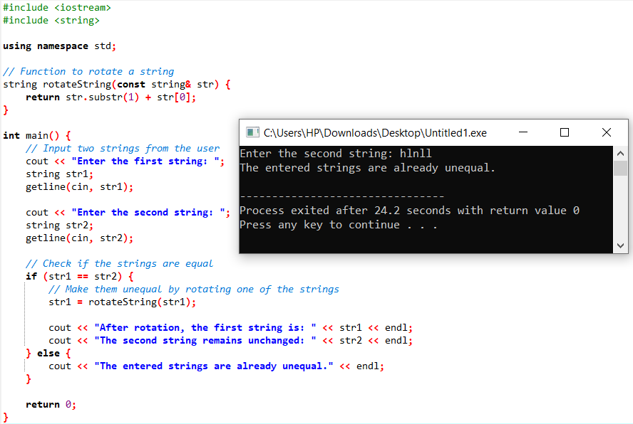

**Description:**

This program uses the rotateString function to rotate the first string, making it unequal to the second string if they were initially equal. The rotated string is then printed, along with the unchanged second string

**Question #02**

Write a C++program for a string which may contain lowercase and uppercase characters. The task is to remove all duplicate characters from the string and find the resultant string.

**Answer**

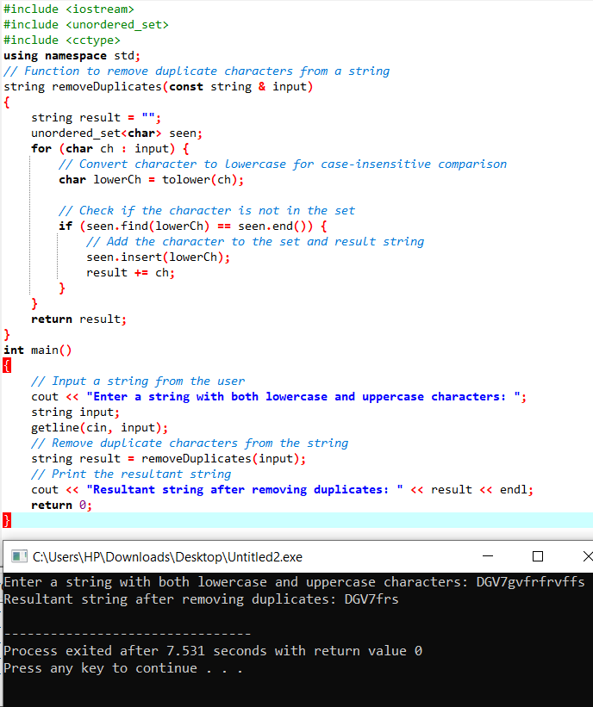

**Description:**

An unordered set is used by this program to record the characters that are viewed when it traverses the input string. To make the comparison case-insensitive, it first changes every character to lowercase (using tolower) before looking for duplicates. Characters that are not already in the set are added to create the final string.

**Question #03**

Suppose an integer array a[5] = {1,2,3,4,5}. Add more elements to it and display them in C++.

**Answer**

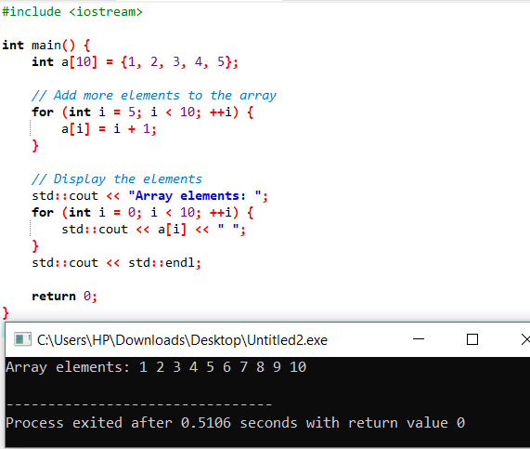

**Description**

This code adds elements 6 through 10 to the array and then prints all 10 elements. Just note that the array is now of size 10, and elements 6 to 10 are initialized in the loop. If you want to make the array dynamic and add elements as needed.

**Question #04**

Write a C++ program that uses a while loop to find the largest prime number less than a given positive integer N. Your program should take the value of N as input from the user and then find the largest prime number less than or equal to N. You are not allowed to use any library or pre-existing functions to check for prime numbers.

**Answer**

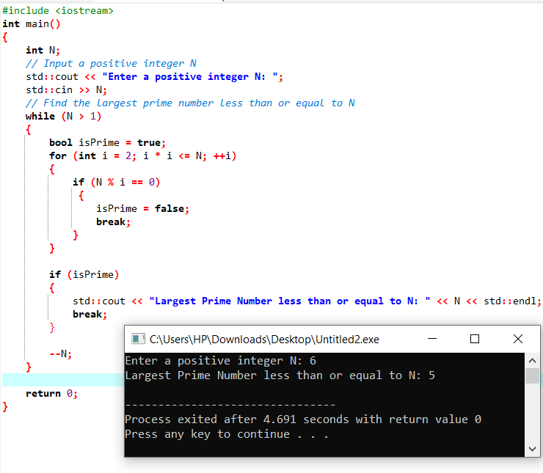

**Description**

This C++ program takes a positive integer N as user input and efficiently finds the largest prime number less than or equal to N using a while loop. It decrements N, checks for primality, and prints the result, terminating after identifying the largest prime number. The program avoids user-defined functions for simplicity

**Question #05**

Implement Bubble Sort on an array of 6 integers

**Answer**

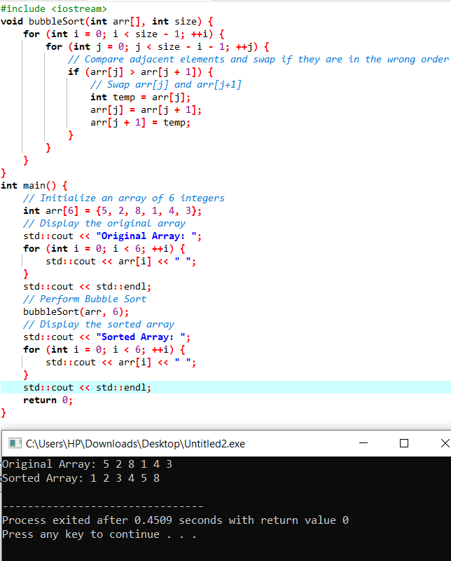

**Description**

This program defines a bubbleSort function to perform the Bubble Sort algorithm on an array. The main function initializes an array of 6 integers, displays the original array, performs the sorting using Bubble Sort, and then displays the sorted array.

**Question #06**

Solve any Aerospace/Real Life Problem using C++ Programming

**Answer**

Let's look at a straightforward real-world aerospace engineering problem: figuring out an aircraft's fuel economy.

Problem statement: Determine and show the fuel economy in miles per gallon (MPG) based on the aircraft's distance flown and fuel consumption.

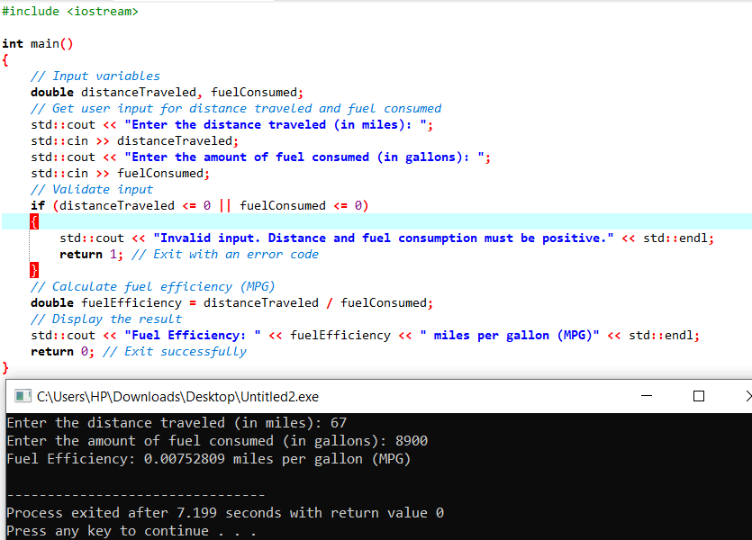

**Description**

In this C++ program, the user is prompted to input the distance traveled and the amount of fuel consumed by an aircraft. The program then calculates the fuel efficiency in terms of miles per gallon (MPG) using the formula:

MPG = distanceTraveled / fuelConsumed. The result is then displayed to the user.This problem is a simplified representation of a common scenario in aerospace engineering, where understanding the fuel efficiency of an aircraft is crucial for optimizing performance and managing resources.